⭐ 1. INNER JOIN

📌 Business Purpose
Retrieve transactions that contain valid customers and products
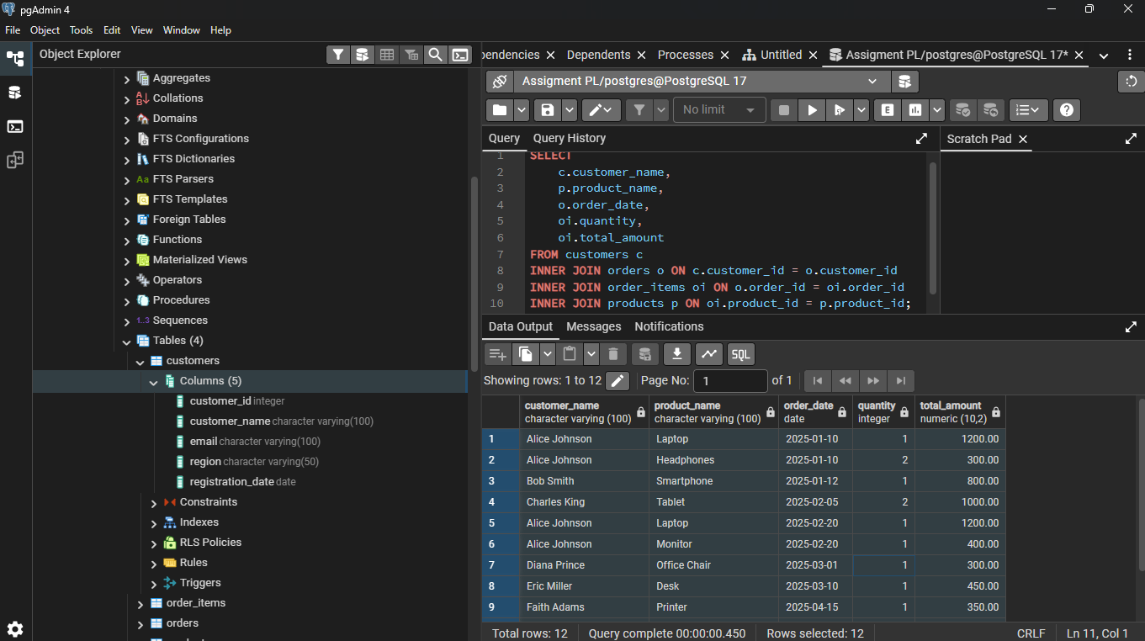

⭐ What This Shows
👉 Only records where ALL tables match
👉 Shows real completed transactions

⭐ 2. LEFT JOIN

📌 Business Purpose
Identify customers who have NEVER placed an order.
(This is very valuable for marketing.)
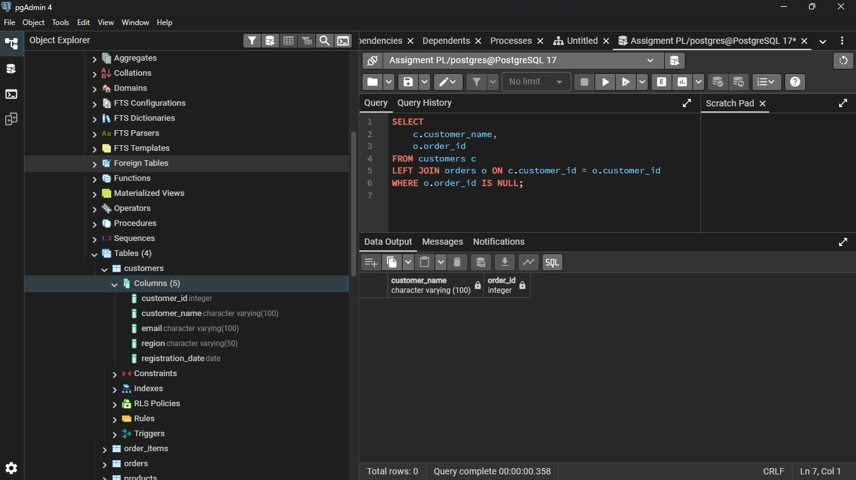

⭐ What This Shows
👉 Customers with no purchases
👉 Potential target customers

⭐ 3. RIGHT JOIN (Detect products with no sales)
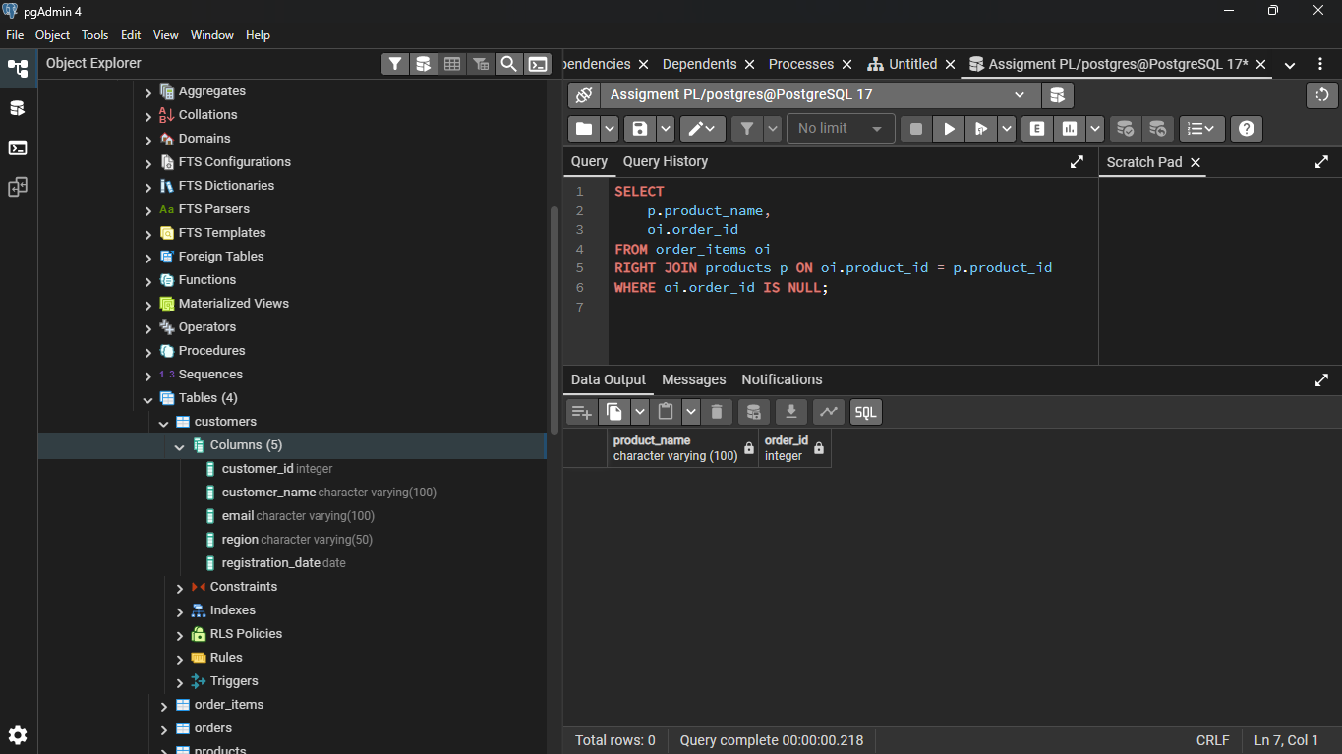

⭐ Business Meaning
👉 Products never sold
👉 Inventory or marketing problem

⭐ 4. FULL OUTER JOIN

📌 Business Purpose
Compare customers and orders including unmatched records.

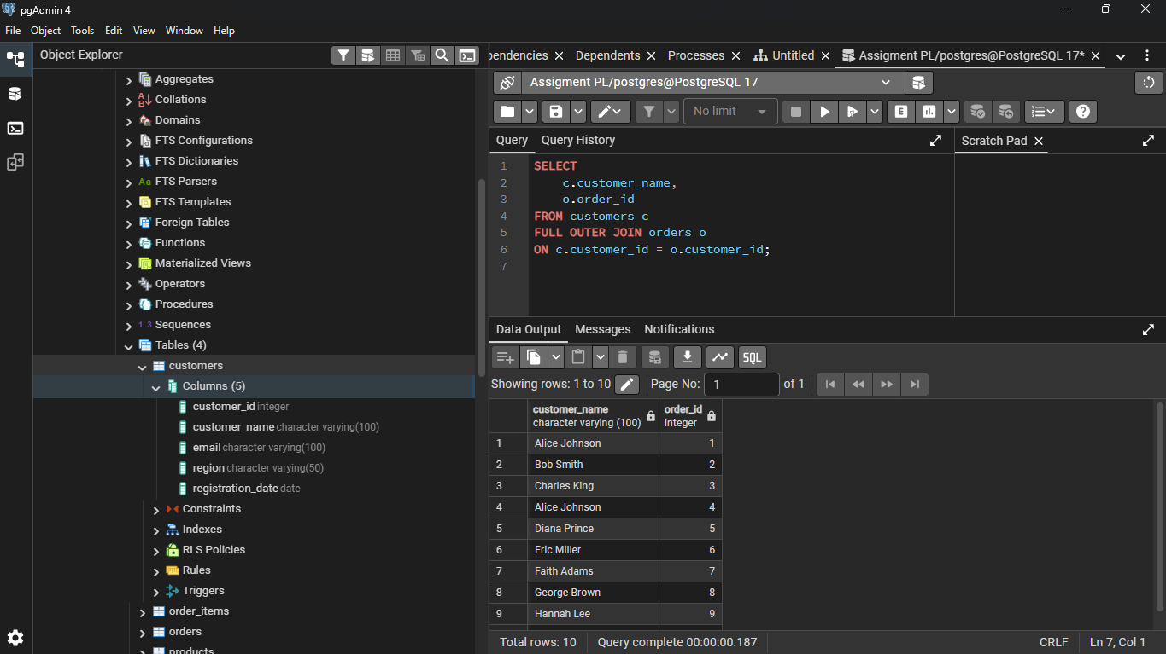

⭐ What This Shows
👉 All customers
👉 All orders
👉 Even unmatched data

⭐ 5. SELF JOIN

📌 Business Purpose

Compare customers in the same region.
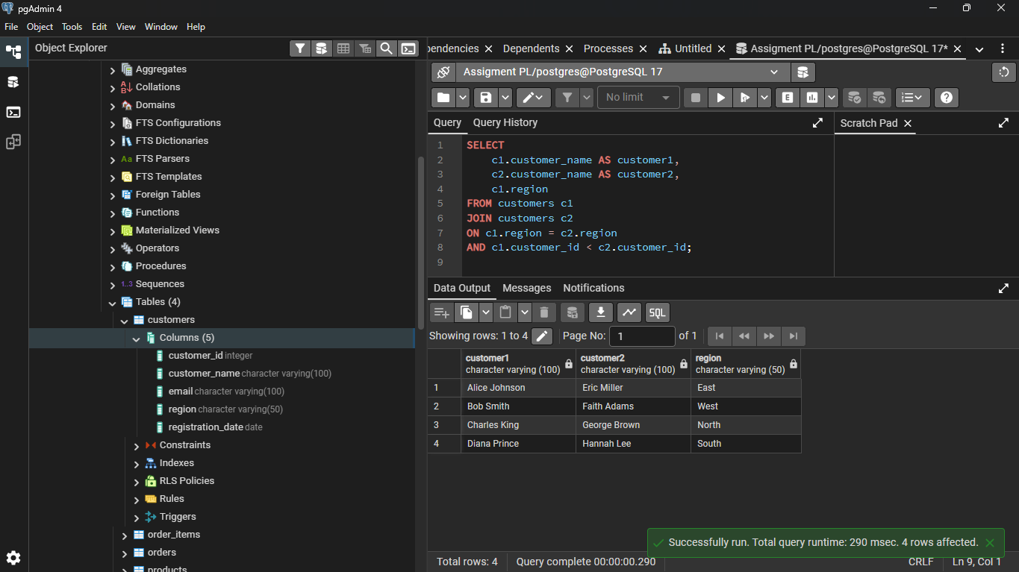

⭐ What This Shows
👉 Customers grouped by region
👉 Useful for regional marketing comparisons

